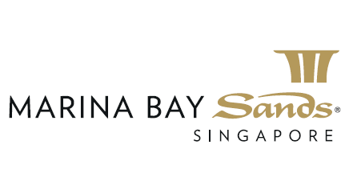

Promotion for Birthday Guest
30% discount for full body massage and spa packages for Birthday Guest, 15% discount for accompanying guest. Applicable on the birthday month for onetime benefit.
Terms & Conditions:
- The offer is valid from 10 Feb 2020 to 31 Dec 2020.
- The offer cannot be used in conjunction with other discounts and promotions.
- The offer is not valid for purchase of products and vouchers.
- Treatment is by appointment and subjected to availability.
- The accompany guest is required to have the treatment on the same date and time with Birthday Guest in order to enjoy the offer.
- The offer is a one-time benefit on the birthday month.
- Payment by cash and credit cards issued by Visa, Master, JCB, Amex and UnionPay only.

